Patient Name: NHS no: Date of Birth:

Bladder diary - Day 1 of 3

Time | Amount of Fluid drunk (mls) | Fluid Type i.e. water, tea | Amount of urine passed (mls) | Urge score (0-4) | Tick if pad or clothes changed
06:00
07:00
08:00
09:00
10:00
11:00
12:00
13:00
14:00
15:00
16:00
17:00
18:00
19:00
20:00
21:00
22:00
23:00
24:00
01:00
02:00
03:00
04:00
05:00
Total: | mls | - | mls | - | -

Patient Name: NHS no: Date of Birth:

Bladder diary – Day 2 of 3

Time | Amount of Fluid drunk (mls) | Fluid Type i.e. water, tea | Amount of urine passed (mls) | Urge score (0-4) | Tick if pad or clothes changed
06:00
07:00
08:00
09:00
10:00
11:00
12:00
13:00
14:00
15:00
16:00
17:00
18:00
19:00
20:00
21:00
22:00
23:00
24:00
01:00
02:00
03:00
04:00
05:00
Total: | mls | - | mls | - | -

Patient Name: NHS no: Date of Birth:

Bladder diary - Day 3 of 3

Time | Amount of Fluid drunk (mls) | Fluid Type i.e. water, tea | Amount of urine passed (mls) | Urge score (0-4) | Tick if pad or clothes changed
06:00
07:00
08:00
09:00
10:00
11:00
12:00
13:00
14:00
15:00
16:00
17:00
18:00
19:00
20:00
21:00
22:00
23:00
24:00
01:00
02:00
03:00
04:00
05:00
Total: | mls | - | mls | - | -

BOWEL DIARY – complete for 7 days

Name: Click or tap here to enter text. NHS no: Click or tap here to enter text. Date of Birth: Click or tap here to enter text.

Date | Time | Stool type  (Type 1 – 7) | Urge score  (0 – 4) | Did anything help you to open your bowels? | Any comments?
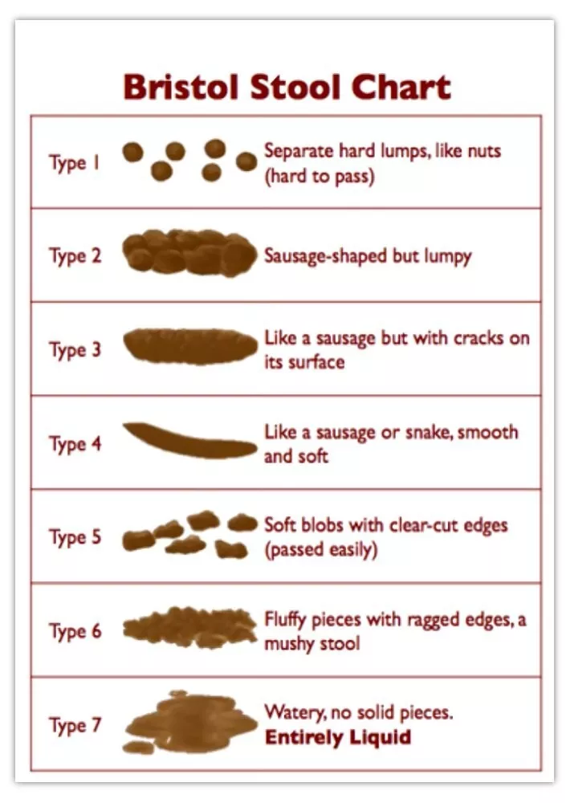

Instructions for Bladder and Bowel Diaries

We have asked you to complete bladder and bowel diaries. These diaries are important as they allow your clinician to understand your symptoms, which helps when we consider any management options or advice we give.

Please complete them as accurately as you can and if you would like to return your completed diaries electronically you can do so by emailing them as an attachment (either photo or scan) to: medch.continencecare@nhs.net

Tips for completing

- Please record as accurately as you can the amount you drink and the amount of urine you pass (if safe to do so and you use a toilet). Every time you pass urine you will need to catch it in a container which has volumes marked on it (e.g. a plastic jug). If you are immobile/bedbound then please tick when you are aware you are passing urine.

- The amount of fluid you have drunk will need to be recorded in mls. All cups, mugs, glasses, bottles and can hold different amounts. If you are not sure what they hold then a useful tip is to fill the container up with water, tip the water into a measuring jug then make a note of the amount in mls. You then know how much that cup type holds going forward.

- You do not have to complete these diaries alone. You can be supported by your family or carers if you have them and wish for them to complete this on your behalf.

Urge score explained- Please read the below scoring system so you can complete the urge score section in your diaries:
0 - No urgency
‘I felt no need to empty my bladder or bowel but did so for other reasons i.e. going out’
1 - Mild urgency
‘I could postpone going for as long as necessary without fear of leakage’
2 - Moderate urgency
‘I could postpone going for a short while without fear of leakage’
3 - Severe urgency
‘I could not postpone going. I had to rush to the toilet in order not to wet or soil myself’
4 – Severe Urgency with wetting/soiling
‘I wet or soiled before I could get to a toilet’

