

Name ________________________________________

Address ________________________________________

DOB ________________________________________

|  |  |  |
| --- | --- | --- |
| **Action** | **Product** | **Frequency** |
| Wash skin with |  |  |
| Dry skin with |  |  |
| Moisturise skin with |  |  |
| Barrier Protection | Derma-S  Proshield wash and spray | After every 3rd wash or incontinence episode |
| 30’ Turns | Ensure that pillows are used to support. Document on turn chart | Each visit |
| Heel Lift | Ensure that a pillow is length ways from under knee to ankle level | Each visit |
| Encourage oral intake | Diet Fluids Supplements | Each visit |
| Monitor pressure areas | Report any red skin that does not fade or any broken skin to community nurses immediately | Each visit |
| Mattress / Cushion | Report if air mattress / cushion is alarming or deflated to community nurses immediately | Each visit |

Nurse Sign ___________________________________________Review Date ____________________________________________

|  |  |  |  |
| --- | --- | --- | --- |
| **Type of equipment** |  |  |  |
| **Date Supplied** |  |  |



What is a Pressure Ulcer?

Pressure ulcers (bedsores) are areas of damage to skin and underlying tissue usually over a body area on the body.

Pressure ulcers usually develop a person has been sitting in the same position for too long without moving.

Areas at Risk of Pressure Ulcers







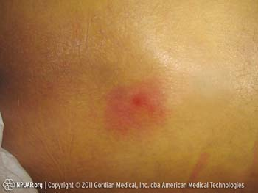Top Tips for Preventing Pressure Ulcers

* SKIN: Inspect the patient’s skin at each visit **– REACT TO RED**. If you notice any red areas you are concerned about refer to the community nurses.
* CLEAN: Use a pH balanced soap. For dry skin use a moisturiser. Pat skin dry – Do not rub.
* MOISTURE: Incontinence will burn the skin. Use barrier products and good skin care. Refer for continence assessment.
* REPOSTIONING: All patients should be encouraged to move themselves. If unable reposition at each visit and a use 30 degree tilt.
* NUTRITION: Good nutrition is essential. Encourage fluid and food at each visit.
* EQUIPMENT: Ensure cushion / mattresses are being utilised and are fit for purpose.

30 Degree Tilt

Reposition patients slightly tilted onto their side with a pillow to support at the back

Who To Contact If you are Concerned

Please contact the Community Nursing service if you notice any red marks that are not fading when pushed or you are concerned your patient may be developing a pressure ulcer.

Contact Phone Number: 0300 1233444